Quantifying the Privacy-Accuracy Trade-off in Horizontal Federated Recommendation: An Empirical Study
^{1st} Soultan Toure Salifou  Faculty of Computing and Informatics  Multimedia University  Cyberjaya, Malaysia  1211104426@student.mmu.edu.my | ^{2nd} Sharaf El-Deen Sami Mohammed Al-Horani  Faculty of Computing and Informatics  Multimedia University  Cyberjaya, Malaysia  sharaf.horani@mmu.edu.my | ^{3rd} Hamza Khaled Mahmoud Ahmed  Faculty of Computing and Informatics  Multimedia University  Cyberjaya, Malaysia  1211309695@student.mmu.edu.my

Abstract- Recommender systems increasingly shape digital experiences. Privacy regulations such as GDPR and CCPA increasingly constrain how recommendation systems collect and process user data, yet the accuracy cost of privacy-preserving alternatives remains poorly characterized. This paper presents controlled experiments comparing horizontal federated and centralized matrix factorization on the Goodreads book dataset to quantify this trade-off. Using identical model architectures and hyperparameters across 18 experimental runs, we establish that standard Federated Averaging incurs a 1.35% RMSE privacy premium—statistically significant but practically modest for most content discovery applications. Scalability analysis across 2–20 client configurations reveals predictable linear degradation (0.016% RMSE per additional client) with stable training times. These findings demonstrate that privacy-preserving collaborative filtering is achievable without prohibitive costs, enabling practitioners to make informed architectural decisions when regulatory constraints require alternatives to centralized data collection.
Keywords—Federated Learning, Recommender Systems, Privacy-Preserving Machine Learning, Matrix Factorization, Horizontal Federated Learning
- Introduction
Billions of daily decisions across entertainment, commerce, news, and social domains are shaped by recommender systems[1]. These systems learn preferences of the user from the data that shows how they behave, their purchase histories, ratings and patterns in their browsing to suggest content that is relevant[1]. These systems however, when centralized, their collection creates privacy risks when aggregated on central servers [2]. Regulations like GDPR, CCPA, and China’s PIPL drive substantial compliance costs [3], transforming privacy from an optional feature to an architectural constraint [4].
Federated learning [5] reconciles data utility with privacy by enabling collaborative training where data remains local and only model updates are communicated to a coordinating server [6]. Horizontal federated learning, where clients share feature space but hold disjoint user samples, naturally maps to recommendation scenarios [2]. Recent surveys document progress in horizontal federated recommendation [4], [7], with studies showing collaborative filtering can be federated without fundamental accuracy loss when user matrices remain local [8], [9]. However, practitioners lack quantitative precision for deployment: point estimates lack confidence intervals, controlled baselines are absent, and scalability analysis is limited [10].

These methodological gaps motivate a controlled comparison of privacy-accuracy trade-offs. Practitioners must assess domain-specific acceptability: content discovery tolerates modest reductions; safety-critical systems cannot. Linear versus exponential degradation patterns fundamentally affect deployment planning [11].
This study addresses these gaps through a controlled comparison of privacy costs in federated collaborative filtering. We investigate:
RQ1: What is the accuracy gap between centralized and horizontal federated systems under identical architectural conditions?
RQ2: How does federated performance and computational efficiency scale with increasing participating clients?
We implement biased matrix factorization on the Goodreads Poetry subset derived from the Goodreads Book Graph [12], [13]. Using this genre-based slice ensures computational efficiency while preserving interaction density for meaningful federated partitioning [14].
Our experimental design uses matched comparisons with identical hyperparameters across multiple random seeds and comprehensive statistical analysis (significance testing, effect sizes, confidence intervals) to isolate federation effects.
Contributions: (1)Controlled benchmark: Rigorous comparison isolating federation as the sole independent variable, addressing prior absence of controlled baselines; (2) Quantified trade-off: 1.35% RMSE privacy premium (p < 0.001, 18 runs) enabling domain-specific acceptability assessments.); (3) Scalability model: Linear degradation (0.016% RMSE per client, R² = 0.75) across 2–20 configurations for capacity planning.
Section II surveys related work. Section III describes our methodology. Section IV presents results. Section V discusses implications and limitations. Section VI concludes.
- Related Work
A. Centralized Collaborative Filtering
Matrix factorization remains dominant for collaborative filtering, with biased matrix factorization establishing the theoretical foundation for privacy-preserving variants [1]. Probabilistic Matrix Factorization (PMF) scales linearly with observations [16], while Alternating Least Squares (ALS) for implicit feedback enables parallelization for distributed training [17]. RMSE and MAE serve as primary metrics [18], with MovieLens as the standard evaluation corpus [19]. While Neural Collaborative Filtering learns complex interactions [20], properly tuned matrix factorization outperforms most deep methods [21], justifying its federated use through interpretability, lower cost, and communication efficiency.
B. Federated Learning Fundamentals
McMahan et al. established FedAvg, where training data remains on devices while shared models learn through aggregated local updates [5], demonstrating 10-100× communication reductions versus synchronized SGD while maintaining robustness to unbalanced and non-IID data [5]. FedProx addresses non-IID challenges through proximal regularization [22], while Li et al. established that data heterogeneity fundamentally slows convergence, explaining federated accuracy degradation [22].
Horizontal FL maps naturally to recommendations with disjoint user sets sharing an item catalog [2], [4], preserving collaborative signals while maintaining data locality [23]. FL provides inherent privacy through data minimization without requiring additional cryptography [23].
C. Federated Recommendation Approaches
Recent surveys establish the landscape: one targets horizontal federated recommendation (HFedRec), noting its dominant position due to user-level privacy feasibility [4], while another covers privacy-preserving techniques calling for effective accuracy-privacy trade-offs [10].
Federated matrix factorization research includes FedMF demonstrating gradient leakage risks and homomorphic encryption protection (with computational overhead) [24], and methods showing collaborative filtering federated without accuracy loss when user matrices stay local with only item-factor gradient communication [8], [9]. MetaMF uses meta-learning for centralized-level performance [25], with robustness confirmed under local differential privacy [26], influencing recent dual-layer systems [27] and lightweight models [28], [29].
Privacy-accuracy trade-offs examined through differential privacy [30] show that stronger privacy (smaller ε) typically reduces accuracy, though surveys highlight limitations from small, non-representative datasets [31].
D. Research Gap
The federated recommendation literature exhibits three critical methodological gaps: (1) Absent privacy-accuracy quantification: Studies lack controlled centralized baselines under identical architectural conditions, preventing isolation of the privacy premium. Without matched comparisons, practitioners cannot determine what accuracy was sacrificed for privacy protection; (2) Missing statistical rigor: Point estimates are reported without confidence intervals, significance tests, effect sizes, or multiple experimental runs, precluding reliable assessment of performance differences; (3) Absence of direct scalability analysis: Client count effects on accuracy remain unexplored, most studies test fixed configurations without systematic evaluation of how performance degrades as participation scales.
These gaps motivate controlled experimental frameworks measuring privacy costs through matched centralized-federated comparisons, comprehensive statistical analysis, and systematic scalability characterization.
- Methodology
This section describes our experimental framework: dataset preparation, model architecture, centralized and federated implementations, and statistical analysis.
A. Dataset and Preprocessing
We use the Goodreads Book Graph Dataset [12], specifically the Poetry Interactions subset with ~2.7M interactions, 377K users, and 36K books.[13]
We apply three preprocessing steps: (1) remove zero-valued ratings (e.g., shelf additions without explicit preference) (2) perform apply iterative k-core filtering with k=20 for seven iterations until convergence, ensuring ≥20 interactions per user/item—matching Goodreads' threshold for personalized recommendations and providing principled minimum-signal for collaborative filtering; (3) map string-based user and item identifiers to contiguous integer IDs for efficient embedding table indexing.
Final dataset: 228,408 ratings across 5,949 users and 2,856 books (38.4 ratings/user, 79.9 ratings/item, 98.65% sparsity). We use 70/10/20 train/validation/test split with fixed test set across experiments.
B. Model Architecture
We employ biased matrix factorization, a well-established collaborative filtering technique that decomposes the user-item interaction matrix into low-rank latent factor representations. We implement this approach within a custom PyTorch Lightning module (LitBiasedMatrixFactorization). The predicted rating for user u and item i is computed as:

$$r_{u}i=μ+b_{u}+b_{i}+p_{u}⋅q_{i}$$

where $μ$ denotes the global mean rating, $b_{u}$ and $b_{i}$ represent user and item bias terms capturing individual rating tendencies, and $p_{u}$and $q_{i}$ are latent factor vectors encoding user preferences and item characteristics respectively. The dot product $p_{u}⋅q_{i}$ captures the affinity between user and item in the learned latent space.
Our MF model uses 25 latent factors, totaling 228,931 trainable parameters (embeddings and biases): 154,674 user-side and 74,257 item-side. Embeddings are initialized from $N(0,0.01^{2})$ and biases to zero. We minimize mean squared error with Adam (lr = 0.01) and apply L2 weight decay of 0.003.
C. Experimental Design
We implement controlled comparison using identical architectures, hyperparameters, and evaluation protocols, isolating data distribution as sole variable. We evaluate three federated configurations (2, 10, 20 clients) against centralized baseline. Each configuration executes three runs with distinct seeds: {0,1,2} for 2-client, {10,11,12} for 10-client, {20,21,22} for 20-client; centralized runs nine times for matched reference distribution.
Training duration controlled for equivalent optimization: centralized executes 8 epochs; federated executes R rounds with E local epochs per round (R × E = 8 total). All preprocessing metadata, checkpoints, and logs version-controlled for reproducibility.
- Centralized Baseline Implementation
The centralized baseline employs a single-server architecture trained for up to 8 epochs with early stopping (patience = 5, min ΔRMSE=0.0001). Performance is evaluated on the held-out test set using the final selected checkpoint. To facilitate paired statistical comparisons, we execute nine independent runs using the consolidated seed set defined in Section C to match the federated performance distribution.
E. Federated Learning Architecture
Federated implementation uses horizontal partitioning with disjoint user subsets sharing item catalog (reflecting regional providers: 2 clients; multi-region clouds: 10 clients; edge networks: 20 clients). Users assigned randomly with fixed seeds.
Data partitions 5,949 users across clients: 2-client (~2,975/client), 10-client (~595/client), 20-client (~297/client). 2-client establishes baseline with maximum local data; higher counts test scalability as datasets sparse.
F. Federated Aggregation Strategy
We employ a custom FedAvgItemsOnly strategy extending standard FedAvg. Each round, clients train local models on their user subsets, updating both user and item parameters. Only item-side parameters (item embeddings, item biases, and global bias) are transmitted to the server for weighted aggregation (proportional to training samples), while user embeddings remain local. The server broadcasts updated global item parameters to all clients. This selective aggregation preserves privacy—user representations never leave clients—while enabling collaborative learning of shared item characteristics.
G. Evaluation Metrics and Statistical Analysis
RMSE serves as the primary metric to emphasize larger errors, supplemented by MAE for robustness. Computational efficiency is quantified by recording training time in seconds.
Statistical comparisons of RMSE between centralized and federated models utilize two-sample t-tests for pooled data and two-sided Mann–Whitney U tests for per-configuration analysis. To control the family-wise error rate across four comparisons, we apply Bonferroni correction (α=0.0125α=0.0125) and report Cohen’s dd as a universal effect-size measure.
The Kruskal-Wallis H-test evaluates RMSE variance across client counts (2, 10, and 20). Scalability is modeled via linear regression to extract the degradation rate (RMSE per additional client) with 95% confidence intervals, while variance analysis assesses result stability at higher client counts.
- Results
This section quantifies the privacy-accuracy trade-off through controlled experiments addressing: (RQ1) the performance gap between centralized and federated approaches, and (RQ2) federated scalability with increasing client count.
A. Overall Performance Comparison
Centralized baseline achieves mean RMSE of 0.9183 (SD=0.0009) versus federated 0.9308 (SD=0.0014), establishing statistically significant cost of 0.0124 RMSE (t=-21.82, p<0.001, d=-10.91)—a 1.35% privacy premium more details in Table I.
- Privacy Premium Analysis Across Client Configurations
Config | Centralized RMSE | Federated RMSE | Δ RMSE | Significant?
2-cl | 0.9183 ± 0.0006 | 0.9295 ± 0.0014 | +0.0112 | No (p=0.1)
10-cl | 0.9188 ± 0.0009 | 0.9304 ± 0.0001 | +0.0115 | No (p=0.1)
20-cl | 0.9178 ± 0.0011 | 0.9324 ± 0.0001 | +0.0146 | No (p=0.1)
Overall | 0.9183 ± 0.0009 | 0.9308 ± 0.0014 | +0.0124 | Yes(p<0.001)*
*Note: Bonferroni-corrected α = 0.013
Federated training shows consistent performance loss across configurations. Figure 1 shows MAE and RMSE remain stable as client count increases.
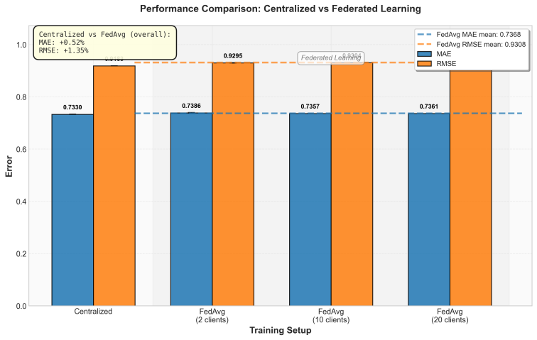
- Performance comparison between centralized and federated learning across client configurations. Both MAE (blue) and RMSE (orange) metrics show consistent performance, with federated learning demonstrating only modest accuracy costs (MAE: +0.52%, RMSE: +1.35%) across all tested configurations. Dashed lines indicate overall federated means.
Fig. 2 shows RMSE distributions across 18 runs, confirming consistent privacy premium with minimal variance.
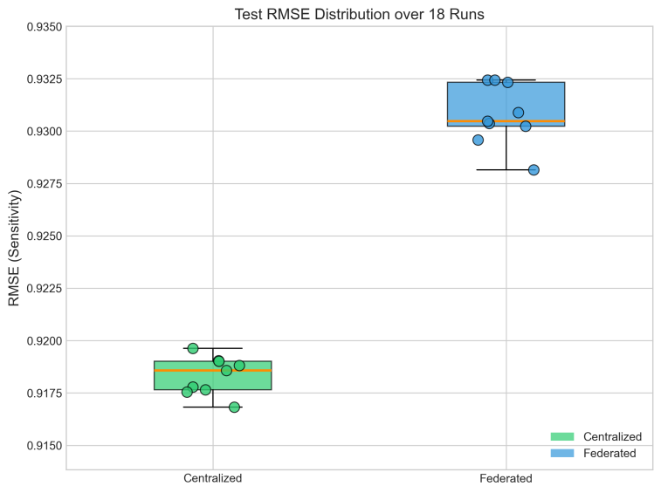
- Box plot comparison of test RMSE distributions over 18 runs. Centralized training (green) achieves lower RMSE with tighter distribution (median = 0.9184, IQR = 0.0006), while federated training (blue) shows systematically higher RMSE with slightly increased variance (median = 0.9306, IQR = 0.0013). Non-overlapping quartile ranges confirm the statistical significance of the privacy premium.
- STATISTICAL SIGNIFICANCE OF PRIVACY-ACCURACY TRADE-OFF
Comparison | Δ RMSE | Privacy Premium | Test Statistic | p-value | Cohen's d | Sig.†
Overall (pooled) | 0.0124 | +1.35% | t = -21.82 | <0.0001 | -10.91 | Yes*
2-client vs baseline | 0.0112 | +1.22% | U = 0.00 | 0.1000 | -12.92 | No
10-client vs baseline | 0.0115 | +1.26% | U = 0.00 | 0.1000 | -21.06 | No
20-client vs baseline | 0.0146 | +1.59% | U = 0.00 | 0.1000 | -22.63 | No
*Note: Significant at α = 0.05
† After Bonferroni correction (α = 0.0125)
The pooled analysis confirms statistical significance (t = -21.82, p < 0.001). Large Cohen's d values (-12.92 to -22.63) reflect measurement precision (SD = 0.0001–0.0011) rather than practical differences. MAE results (centralized: 0.7330, federated: 0.7361–0.7386) corroborate these findings. Beyond the endpoint accuracy comparison, the training dynamics reveal how both paradigms achieve convergence. Fig. 3 shows both paradigms converge quickly with stable, low-variance trajectories.
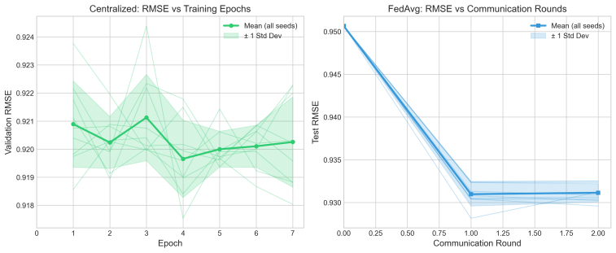
- Training dynamics comparison between centralized and federated learning. Left: Centralized RMSE converges smoothly within 2 epochs to stable performance around 0.920 with minimal variance across seeds. Right: Federated RMSE decreases monotonically across communication rounds, achieving convergence by round 1 at approximately 0.931 with tight confidence bands indicating consistent aggregation across clients.
B. Scalability Analysis
Fig. 4 shows modest linear degradation with increasing client count, indicating stable training.

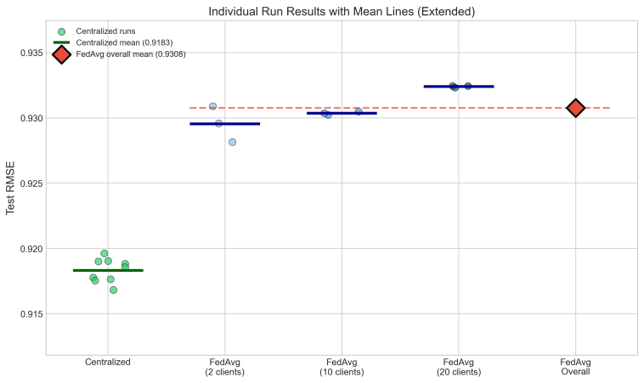
- Scalability analysis showing individual run results with mean lines. Centralized performance (green circles, mean = 0.9183) remains stable across different seed groups, while federated performance (blue circles and lines) exhibits predictable degradation with increasing client count. The overall federated mean (red diamond, 0.9308) represents the aggregate privacy premium across all configurations. Horizontal lines show mean RMSE for each configuration.
Kruskal–Wallis H-test (H=5.60, p=0.061) indicates federated performance remains stable across 2, 10, and 20 clients. Standard deviations decrease (0.0011 for 2-client to 0.0001 for 10/20-client), indicating increased consistency at higher client counts due to FedAvg’s averaging effect.
C. Computational Efficiency
Computational parity achieved: centralized averages 294.7s (SD=46.6) versus federated 291.3s (SD=78.5)—0.99× ratio (Mann–Whitney U=41.0, p=1.0).
- SCALABILITY ANALYSIS
Configuration | n | Mean Time (s) | SD (s) | Min–Max (s) | Time Ratio
Centralized | 9 | 294.7 | 46.6 | 224.6–369.7 | 1.00×
Federated (2-cl) | 3 | 275.8 | 54.9 | 212.8–313.7 | 0.94×
Federated (10-cl) | 3 | 250.3 | 89.0 | 192.7–352.9 | 0.85×
Federated (20-cl) | 3 | 347.8 | 77.6 | 285.2–434.6 | 1.18×
Federated (all) | 9 | 291.3 | 78.5 | 192.7–434.6 | 0.99×

Individual configurations vary (10-client: 15% faster; 20-client: 18% slower), but overall parity indicates negligible communication overhead.
- Discussion
A. Interpreting the Privacy Premium
The 1.35% RMSE privacy premium indicates horizontal federated recommendation achieves near-parity using standard FedAvg, without advanced variants (FedProx, SCAFFOLD, momentum methods). This supports the feasibility of low-complexity deployment in regulated settings. Prior differential-privacy-protected recommendation studies report accuracy drops exceeding 37% for strong guarantees (ε ≤ 0.1) [30], [31]; our data-locality approach incurs substantially lower cost (1.35%) by avoiding noise injection, though it provides weaker formal privacy guarantees than DP mechanisms.
The high statistical significance (t = −21.82, p < 0.001) reflects measurement precision rather than practical impact: ΔRMSE = 0.0124 corresponds to ≈ 0.06 rating points on a 5-point scale, which is unlikely to be perceptible in typical deployments. Low standard deviations (SD = 0.0001–0.0014 RMSE) indicate reproducible performance and enable confident deployment planning.
Figure 3 suggests the premium arises primarily from distributed initialization rather than aggregation inefficiency. Federated models reach stable performance after the first communication round, indicating FedAvg effectively coordinates heterogeneous clients. Improved initialization (public-data pre-training, transfer learning) may further reduce the remaining gap.
B. Domain Acceptability
The 1.35% privacy premium quantifies regulatory compliance trade-offs. Modest accuracy reductions often outweigh GDPR/CCPA enforcement costs and infrastructure overhead, though acceptability is strictly domain-dependent.
For content discovery domains (books, media, news), the trade-off proves negligible. The observed 0.0124 RMSE increase is overshadowed by the intrinsic noise of human rating variability, rendering degradation imperceptible while establishing competitive differentiation [32].
In e-commerce, where accuracy correlates with revenue, deployment requires calculated ROI analysis. We recommend a two-stage validation: shadow deployment to confirm production-scale RMSE gaps, followed by A/B testing to measure conversion rate elasticity against the 1.35% accuracy drop.
Conversely, safety-critical domains (healthcare, financial advisory) cannot justify performance compromise. Standard FedAvg proves insufficient here, necessitating hybrid architectures or advanced federated optimization with tighter convergence guarantees.
- Design Implications
Our findings using the standard FedAvg demonstrates strong privacy-preserving performance with bounded cost, establishing an empirical baseline that invites exploration of what advanced algorithms might achieve. Stable accuracy across 2–20 clients (p=0.061) allows flexible partitioning while raising questions about potential gains from sophisticated approaches. Computational parity (0.99× ratio) sets a performance horizon that motivates investigation into whether alternatives can push beyond these benchmarks; however, real-world network latency, client availability, and synchronization overhead present compelling opportunities to validate how advanced strategies perform under realistic distributed conditions before architectural commitments.
D. Limitations and Future Work
1) IID Data Partitioning: Random assignment doesn’t reflect real deployments with systematic user differences (geography, demographics, preferences). non-IID settings increase gradient divergence suggesting our 1.35% premium is a lower bound. Future: characterize trade-offs under varying non-IID degrees via synthetic partitions (Dirichlet) and real-world geographic distributions; evaluate FedProx-like strategies [22].
2) Absence of Differential Privacy: Data locality prevents centralization but lacks formal assurances. Future: quantify incremental costs across ε budgets (0.1–10) with differential privacy/secure aggregation; evaluate overhead versus privacy gains.
3) MF Baseline: Matrix factorization provides rigorous baseline; deep learning may differ. Future: extend to neural collaborative filtering, graph neural networks, and transformer-based sequential models.
4) Controlled Experimental Setting: Single-machine simulation may underestimate network latency, hardware heterogeneity, and client dropout costs. Future: validate under realistic distributed conditions (heterogeneous devices, wide-area networks, asynchronous aggregation); extend to implicit feedback, session-based recommendation, and cold-start scenarios.
- Conclusion
This work provides statistically rigorous quantification of the privacy-accuracy trade-offs in horizontal federated recommendation via controlled experiments comparing centralized and federated matrix factorization. Standard Federated Averaging incurs 1.35% RMSE privacy premium (p<0.001) with computational parity. Scalability analysis reveals predictable linear degradation (0.016% RMSE per client, R²=0.75) across 2–20 clients with equivalent training times (0.99× ratio).
These findings enable informed architectural decisions: 0.0124 RMSE (~0.06 rating points) is acceptable for content discovery but potentially problematic for safety-critical domains. Our methodology addresses prior gaps through matched conditions, comprehensive statistical analysis, and systematic scalability characterization. Despite limitations (IID assumptions, no formal privacy guarantees, classical architectures, controlled environments), this work provides quantitative foundations for evidence-based architectural decisions under regulatory constraints.
References
[1] Y. Koren, R. Bell, and C. Volinsky, “Matrix factorization techniques for recommender systems,” Computer, vol. 42, no. 8, pp. 30–37, Aug. 2009, doi: 10.1109/MC.2009.263.
[2] Q. Yang, Y. Liu, T. Chen, and Y. Tong, “Federated machine learning: concept and applications,” ACM Trans. Intell. Syst. Technol., vol. 10, no. 2, pp. 1–19, Jan. 2019, doi: 10.1145/3298981.
[3] L. Monteiro Krebs et al., “Tell me what you know: GDPR implications on designing transparency and accountability for news recommender systems,” in Proc. Extended Abstracts 2019 CHI Conf. Human Factors in Computing Systems (CHI EA ’19), 2019, pp. 1–6, doi: 10.1145/3290607.3312808.
[4] L. Wang, et al., “Horizontal federated recommender system: a survey,” ACM Comput. Surv., vol. 56, no. 9, art. 240, May 2024, doi: 10.1145/3656165.
[5] H. B. McMahan, E. Moore, D. Ramage, S. Hampson, and B. A. y Arcas, “Communication-efficient learning of deep networks from decentralized data,” in Proc. 20th Int. Conf. Artif. Intell. Stat. (AISTATS), Fort Lauderdale, FL, USA, Apr. 2017, pp. 1273–1282. [Online]. Available: https://arxiv.org/abs/1602.05629
[6] K. Bonawitz et al., “Practical secure aggregation for privacy-preserving machine learning,” in Proc. 2017 ACM SIGSAC Conf. Computer and Communications Security (CCS ’17), 2017, pp. 1175–1191, doi: 10.1145/3133956.3133982.
[7] Z. Sun et al., “A survey on federated recommendation systems,” IEEE Trans. Neural Netw. Learn. Syst., 2023, doi: 10.48550/arXiv.2301.00767.
[8] M. Ammad-ud-din, E. Ivannikova, S. A. Khan, W. Oyomno, Q. Fu, K. E. Tan, and A. Flanagan, “Federated collaborative filtering for privacy-preserving personalized recommendation system,” 2019, arXiv:1901.09888. [Online]. Available: https://arxiv.org/abs/1901.09888
[9] V. Perifanis and P. S. Efraimidis, “Federated neural collaborative filtering,” Knowl.-Based Syst., vol. 249, p. 108441, 2022, doi: 10.1016/j.knosys.2022.108441.
[10] M. Asad, S. Shaukat, E. Javanmardi, J. Nakazato, and M. Tsukada, “A comprehensive survey on privacy-preserving techniques in federated recommendation systems,” Applied Sciences, vol. 13, no. 10, art. no. 6201, May 2023, doi: 10.3390/app13106201.
[11] T. Li, A. K. Sahu, A. Talwalkar, and V. Smith, “Federated learning: challenges, methods, and future directions,” IEEE Signal Process. Mag., vol. 37, no. 3, pp. 50–60, May 2020, doi: 10.1109/MSP.2020.2975749.
[12] M. Wan and J. McAuley, “Item recommendation on monotonic behavior chains,” in Proc. 12th ACM Conf. Recommender Systems (RecSys ’18), 2018, pp. 86–94.
[13] M. Wan, R. Misra, N. Nakashole, and J. McAuley, “Fine-grained spoiler detection from large-scale review corpora,” in Proc. 57th Annu. Meeting Assoc. Computational Linguistics (ACL ’19), 2019, pp. 2605–2610.
[14] M. Wan, “Goodreads datasets,” 2025, GitHub repository. [Online]. Available: https://github.com/MengtingWan/goodreads
[15] R. Li, at al., “Federated cross-view e-commerce recommendation based on feature rescaling,” Scientific Reports, vol. 14, art. no. 29926, Dec. 2024, doi: 10.1038/s41598-024-81278-1.
[16] R. Salakhutdinov and A. Mnih, “Probabilistic matrix factorization,” in Advances in Neural Information Processing Systems 20 (NIPS 2007), Vancouver, BC, Canada, 2008, pp. 1257–1264.
[17] Y. Hu, Y. Koren, and C. Volinsky, “Collaborative filtering for implicit feedback datasets,” in 2008 Eighth IEEE Int. Conf. Data Mining, Pisa, Italy, 2008, pp. 263–272, doi: 10.1109/ICDM.2008.22.
[18] A. Gunawardana and G. Shani, “A survey of accuracy evaluation metrics of recommendation tasks,” J. Mach. Learn. Res., vol. 10, pp. 2935–2962, 2009.
[19] F. M. Harper and J. A. Konstan, “The MovieLens datasets: History and context,” ACM Trans. Interactive Intell. Syst., vol. 5, no. 4, art. no. 19, pp. 1–19, Dec. 2015, doi: 10.1145/2827872.
[20] X. He et al., “Neural collaborative filtering,” 2017, arXiv:1708.05031. [Online]. Available: https://arxiv.org/abs/1708.05031
[21] S. Rendle, W. Krichene, L. Zhang, and J. Anderson, “Neural collaborative filtering vs. matrix factorization revisited,” 2020, arXiv:2005.09683. [Online]. Available: https://arxiv.org/abs/2005.09683
[22] T. Li, A. K. Sahu, M. Zaheer, M. Sanjabi, A. Talwalkar, and V. Smith, “Federated optimization in heterogeneous networks,” 2020, arXiv:1812.06127. [Online]. Available: https://arxiv.org/abs/1812.06127
[23] P. Kairouz et al., “Advances and open problems in federated learning,” Proc. IEEE, vol. 109, no. 1, pp. 1–36, Jan. 2021, doi: 10.1109/JPROC.2020.3038268.
[24] D. Chai, L. Wang, K. Chen, and Q. Yang, “Secure federated matrix factorization,” IEEE Intell. Syst., vol. 35, no. 4, pp. 82–88, 2020, doi: 10.1109/MIS.2020.3014880.
[25] Y. Lin, et al., “Meta matrix factorization for federated rating predictions,” in Proc. 43rd Int. ACM SIGIR Conf. Research and Development in Information Retrieval (SIGIR ’20), 2020, pp. 981–990, doi: 10.1145/3397271.3401081.
[26] P. Muellner, D. Kowald, and E. Lex, “Robustness of meta matrix factorization against strict privacy constraints,” in Advances in Information Retrieval (ECIR 2021), LNCS 12657, Springer, Cham, 2021, pp. 107–119, doi: 10.1007/978-3-030-72240-1_8.
[27] Q. Yue and X. Tong, “A federated recommendation system with a dual-layer multi-head attention network and regularization strategy,” Entropy, vol. 27, no. 11, p. 1112, 2025, doi: 10.3390/e27111112.
[28] H. Zhonglei, L. Fangyuan, W. Jun, H. Xiangnan, and L. Yidong, “LightFR: Lightweight federated recommendation with privacy-preserving matrix factorization,” ACM Trans. Inf. Syst., vol. 41, no. 4, art. no. 90, pp. 1–28, Mar. 2023, doi: 10.1145/3578361.
[29] S. Li, D. Wu, Y. He, and X. Luo, “Federated projection Hamming hash latent factor learning model,” in 2025 28th Int. Conf. Computer Supported Cooperative Work in Design (CSCWD), IEEE, 2025, doi: 10.1109/CSCWD64889.2025.11033266.
[30] P. Müllner, E. Lex, M. Schedl, and D. Kowald, “The impact of differential privacy on recommendation accuracy and popularity bias,” in Advances in Information Retrieval (ECIR 2024), N. Goharian et al., Eds., LNCS, vol. 14611. Cham, Switzerland: Springer, 2024, pp. 466–482, doi: 10.1007/978-3-031-56066-8_33.
[31] P. Müllner, E. Lex, M. Schedl, and D. Kowald, “Differential privacy in collaborative filtering recommender systems: a review,” Frontiers in Big Data, vol. 6, Oct. 2023, art. no. 1249997, doi: 10.3389/fdata.2023.1249997.
[32] A. Aramanda, S. Md. Abdul, and R. Vedala, “Refining user ratings using user emotions for recommender systems,” in Proc. 23rd Int. Conf. Information Integration and Web Intelligence (iiWAS 2021), 2021, pp. 3–10, doi: 10.1145/3487664.3487666.

